Mark 5 recorder decimation and data rate

When connected to the DBBC the MK5 recorder receives a external 32 MHz clock via the VSI interface cable.

To make use of this it is necessary to issue the command clock_set = 32:ext from the tstdimino command line interface on the mk5 or telnet to the mk5 on port 2620. The ext part of the command forces the MK5 to look on the VSI interface for a clock signal.

It is important to note that this is not the end of configuration though; we must also instruct the recorder as to how to divide this (external) clock down to derive the actual sampling rate it will use during recording.

In the diagram above D = “decimation ratio” = clock division ratio. So we have;
MK5 recorder
32 MHz on VSI cable
÷ D
X MHz recording clock

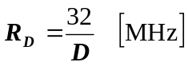 (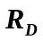= recording rate in MHz).

In turn the desired recording rate is actually a function of the Channel bandwidth that we want to record;

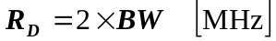 (we want to Nyquist sample the recorded BW!)

So we have;

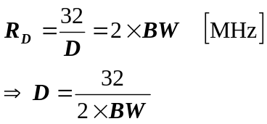 (all freqs in MHz)

Let;

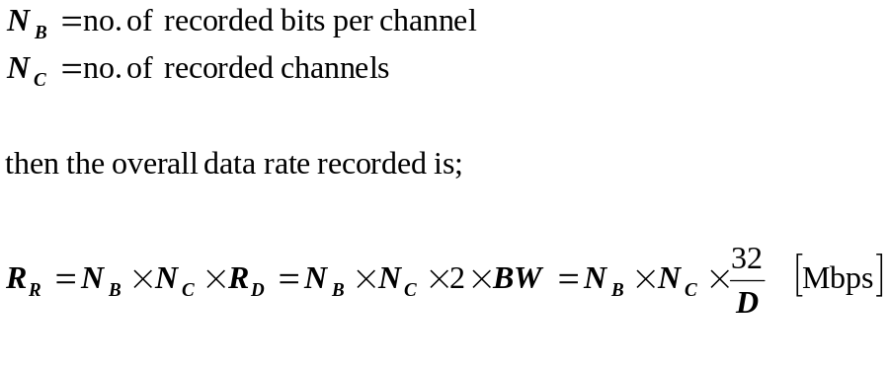

So for example to record 16 channels of 8 MHz bandwidth, 1 bit per channel with a decimation ratio of 2 we will end up with an overall data rate of;

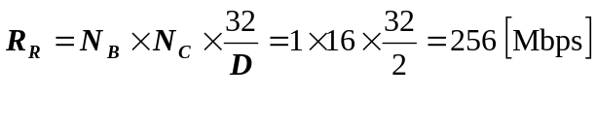

Alternatively if we want to record 4 MHz bandwidth per channel then we can immediately compute that we need a decimation ratio of;

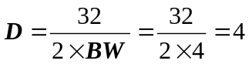

If we then want 1 bit per channel, 16 channels we will end up with an overall data rate of;

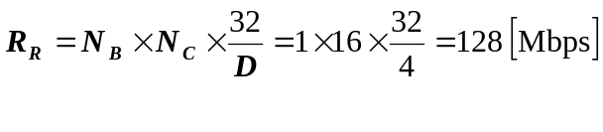
In this last case the mode for the MK5 should be set as;

>mode_set = ext:0x55555555:4
decimate by 4
use external clock
1 bit per channel

